Equality & Diversity Monitoring Form
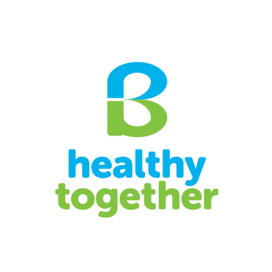

Your information will be stored securely and used anonymously. We will not pass your details onto other organisations without your permission. To access the information we hold about you, or to be removed from our database, please contact B Healthy Together.

- What is your gender?
- Male Female Prefer not to say
- What is your main language?
English Gaelic Polish Spanish Portuguese Romanian
Chinese Turkish Arabic Bengali Urdu/Punjabi Russian
Other, please write in_______________________________
- What age group are you in?
16-30 years 30-50 years 50-70 years 70+ years
- What is your ethnic group?
White
Scottish Other British Irish
Any other white background, please write in _____________________________________________
Mixed
Any mixed background, please writes in _________________________________________________
Asian, Asian Scottish or Asian British
Indian Pakistani Bangladeshi Chinese
Any other Asian background, please write in _____________________________________________
Black, Black Scottish or Black British
Caribbean African
Any other Black background, please write in ______________________________________________
Other ethnic background
Any other background, please write in __________________________________________________

- Disability or long term health impairments. Does a condition or illness affect you in any of the following areas? Tick all that apply:
Deafness or severe hearing impairment
Blindness or severe visual impairment
Mobility - difficulty in walking short distances or climbing stairs
Dexterity – difficulty in lifting or carrying objects, using a keyboard
Learning or understanding or concentrating
Memory
Mental health
Stamina or breathing or fatigue
Socially or behaviourally, for example Autism
Attention Deficit Disorder or Aspergers’ syndrome
A chronic illness (such as cancer, HIV, diabetes, heart disease or epilepsy)
Other condition that affects your ability to carry out everyday tasks
None
Prefer not to answer

